ELEG 312 - Example Problems Chapter 8-1

**Example 8.1**

Given *VDD* = 3 V and using *I*REF =100 μA, design the circuit of Fig. 8.1 to obtain an output current whose nominal value is 100 μA. Find R if *Q*1 and *Q*2 are matched and have channel lengths of 1 μm, channel widths of 10 μm, *Vt* = 0.7 V, and  = 200 μA/V2. What is the lowest possible value of *VO*? Assuming that for this process technology, the Early voltage  =20 V/μm, find the output resistance of the current source. Also, find the change in output current resulting from a +1-V change in *VO*.

given:

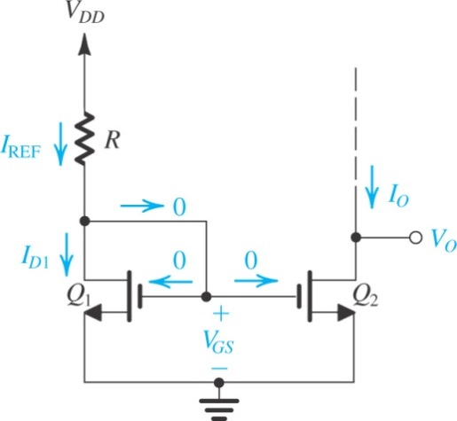*VDD* = 3 V

*I*REF = 100 uA

*L* = 1 um

*W* = 10 um

*Vt* = 0.7 V

*kn'* = 200 uA/V2

*V’A* = 20 V/um

find:

*R*

*VOmin*

*RO* of the current source

**Exercise D8.4**

Assuming the availability of BJTs with scale currents *Is* = 10-15 A, ** = 100, and *VA* = 50 V, design the current-source circuit of Fig. 8.9 to provide an output current *IO* = 0.5 mA at *VO* = 2 V. The power supply *VCC* = 5 V. Give the values of *I*REF, *R,* and *VOmin.* Also, find *IO* at *VO* = 5 V.

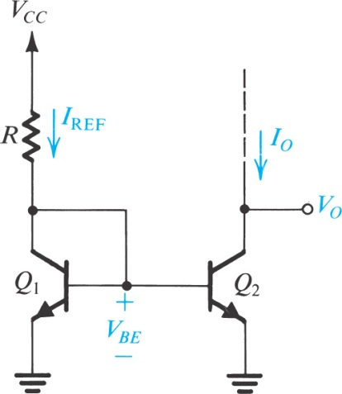

given:

*Is* = 10-15 A

** = 100

*VA* = 50 V

*IO* = 0.5 mA @ *VO* = 2 V

find:

*I*REF

*R*

*VOmin*

*IO* @ *VO* = 5 V.

**Exercise D8.6**

The MOSFETs in the current mirror of Fig. 8.12(a) have equal channel lengths, *μnCox* =400 μA/V2, and V’A = 20 V/μm. If the input bias current is 100 μA, find *W*1, *W*2, *L*1,and *L*2 to obtain a short-circuit current gain of 5, an input resistance of 1 k, and an output resistance of 40 k.

